**WoW Classic Guild Website User Manual**



**Table of Contents**

* 1. **Introduction/Homepage**
  2. **Login/Signup**
  3. **Editing your profile**
  4. **Start a new connection/Update a connection**
  5. **Sign Out**
  6. **Sample User Information**

**I. Introduction/Homepage**

* + 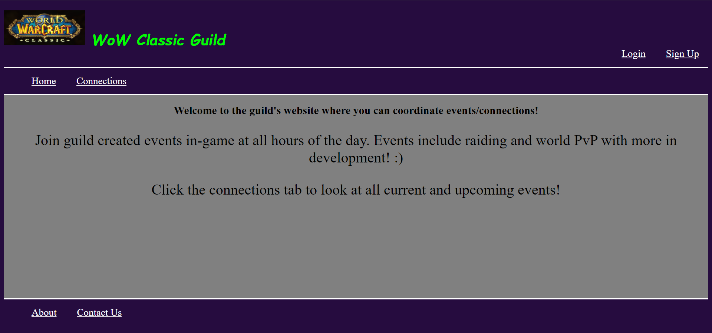Welcome to a Classic WoW guild’s website,

where you can start new connections, update ones of your own, sign up for connections others have created as well as respond to them with a “Yes”, “No”, or “Maybe”. Feel free to delete these connections from your profile’s saved connections list at any time. Furthermore, if you are the creator of an event and go to delete your connection, it will automatically be removed for everyone.

* + 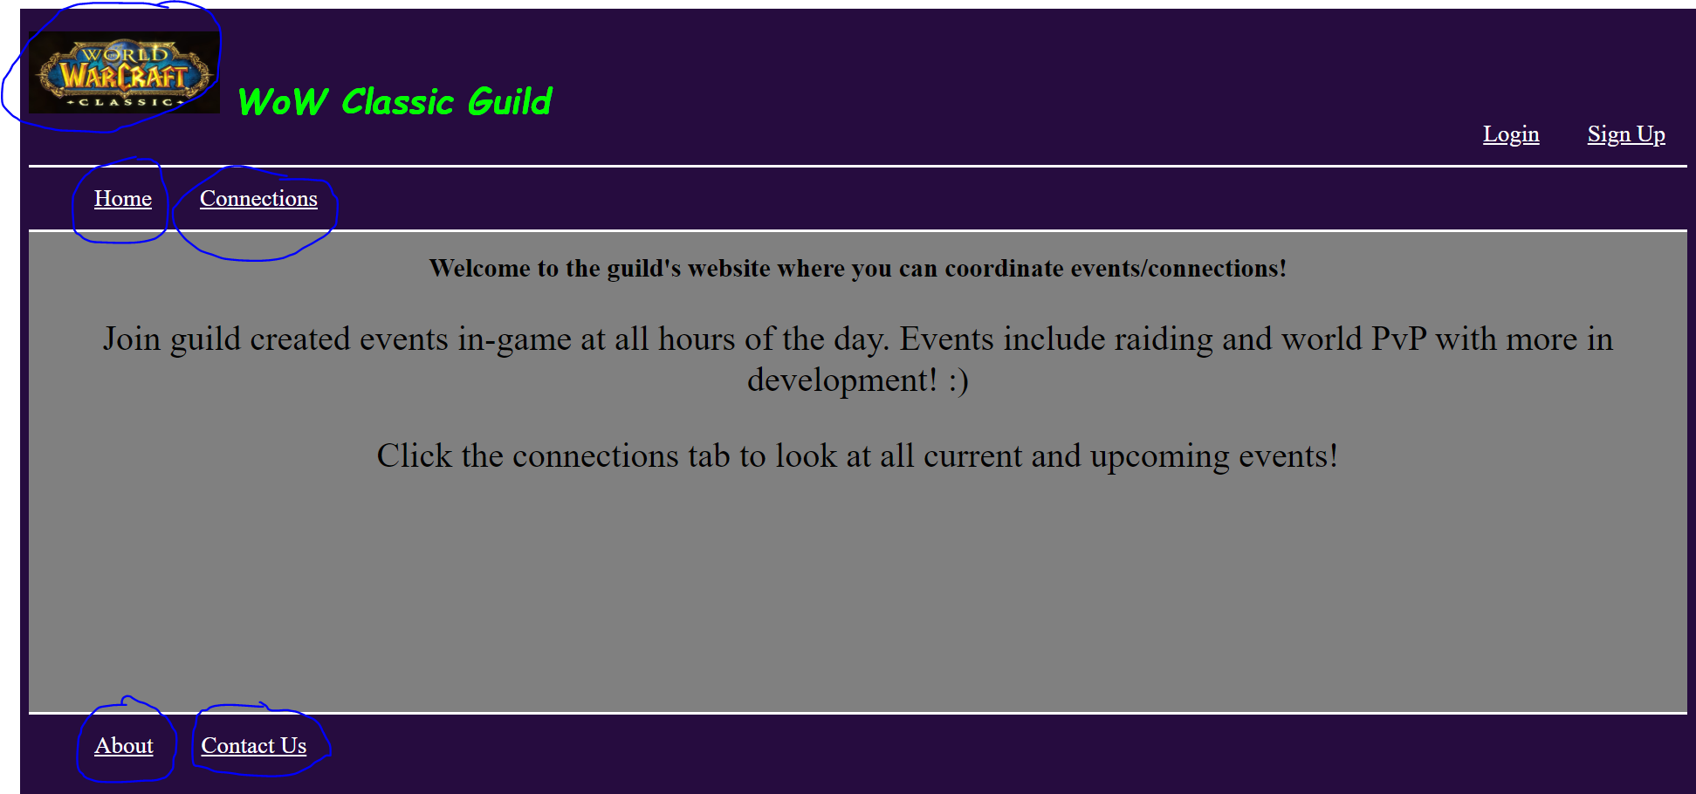First thing’s first are the static links to general pages. These are available to everyone logged in or not. They include the homepage, connections page, about page, and the contact page. The links to these pages are always shown and their links are circled in the picture below.

**II. Login/Signup**

* + 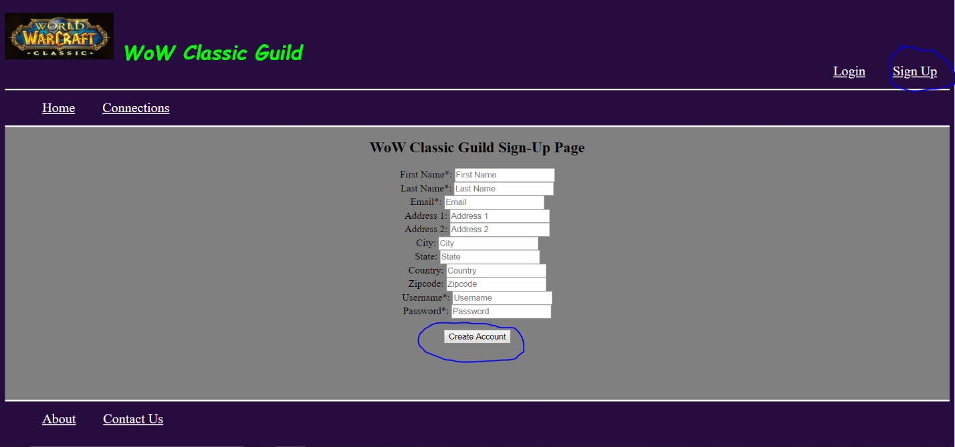To be able to start a new connection, rsvp to one, or delete a saved connection you must be logged in. If you do not have an account and wish to sign up for one, simply click on the sign-up link located in the top right corner of the website and you will be redirected to the guild’s sign-up page. From here you can enter your information and create your account for free. The required fields are marked with an asterisk. Once your sign up is successful, you will be logged into your account and you can begin to add/update/delete connections to your profile.
* 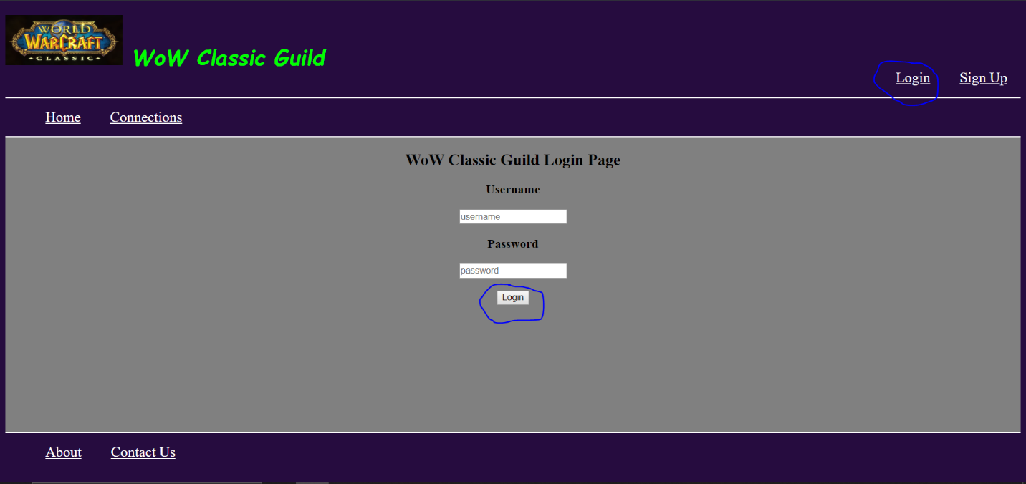If you already have an account, simply login by clicking the Login link located in the top-right corner of the website. Then input your username and password into the provided fields and click the login button right below them.

**III. Editing your profile**

* Upon successfully logging in, you are directed to your saved connections, also called your profile. From here you are able to view all your currently saved connections as well as edit and delete them. Note that if you just signed up, this table will be empty. Come back to this page at any time while logged in by clicking on the “My Connections” link in the top left, circled in yellow in the picture below.

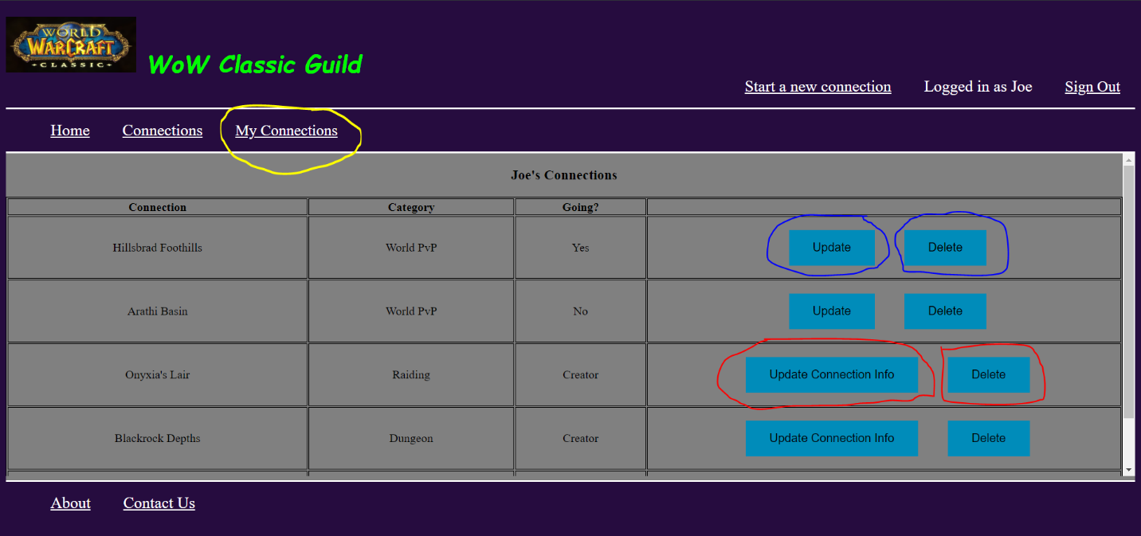

* If the “Update” button is clicked the user is navigated to the specific connection’s page where they can then click “Yes”, “Not Going”, or “Maybe” to update their rsvp. Clicking the “Delete” button will remove the connection from their list of saved connections.
* Note that the “Update” button is changed to the “Update Connection Info” button for connections for which the user is the creator. When clicked, this will redirect the user to the “update a connection” page which provides a form that allows the creator of the connection to update connection info at any time. Clicking on the “Delete” button for created connections will remove the connection from the database as well as remove it from any user’s table who had saved the connection.

**IV. Rsvp to a connection**

* Any user registered with the website and logged in is able to add connections to their profile by visiting the connection’s specific page and clicking on the “Yes”, “Not Going”, or “Maybe” buttons. Clicking on any of these buttons will add the connection to your profile with the rsvp you chose. Similarly, clicking the “Yes”, “Not Going”, or “Maybe” buttons will update the rsvp you currently have to the one you chose.

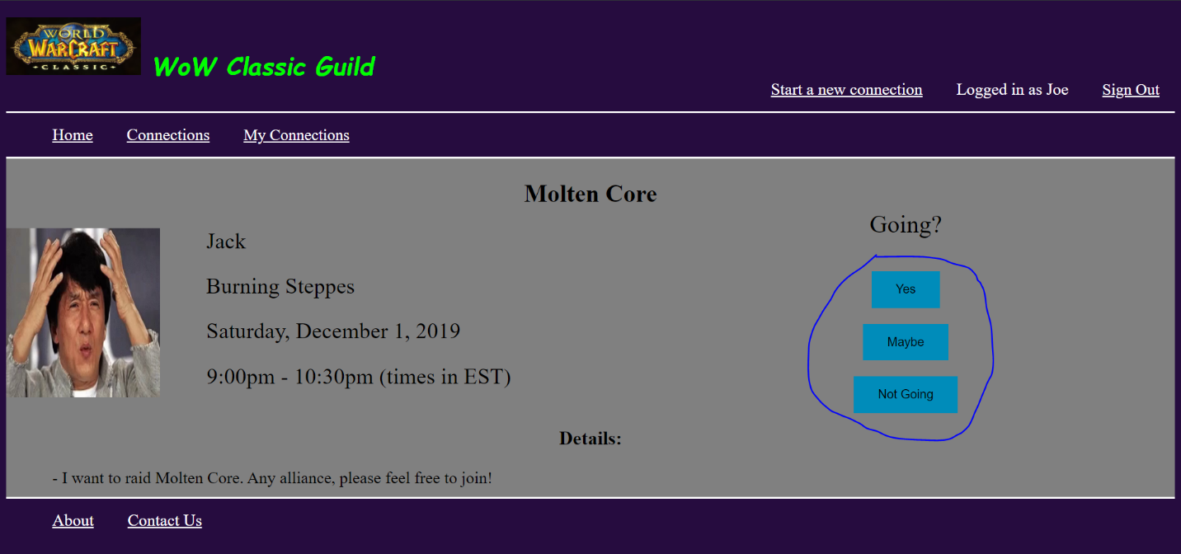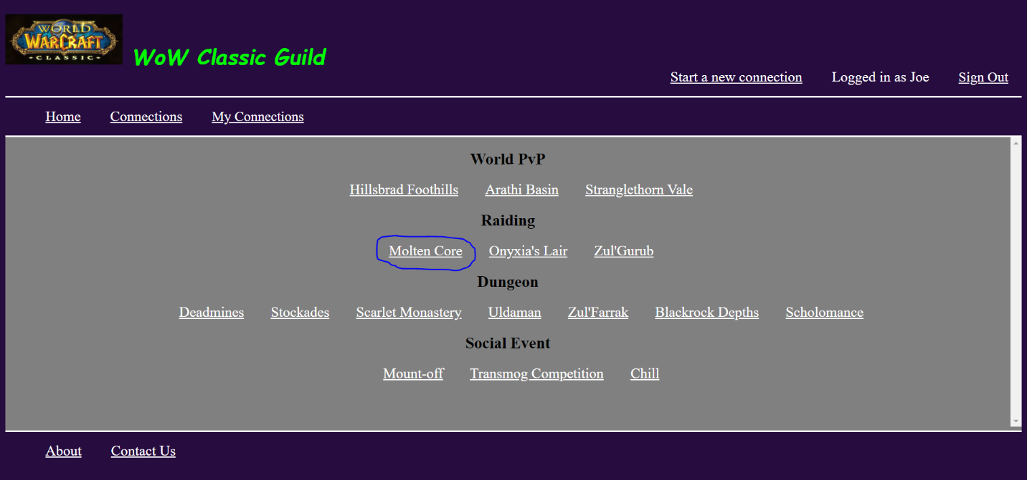

**IV. Starting a new connection/Updating a connection**

* 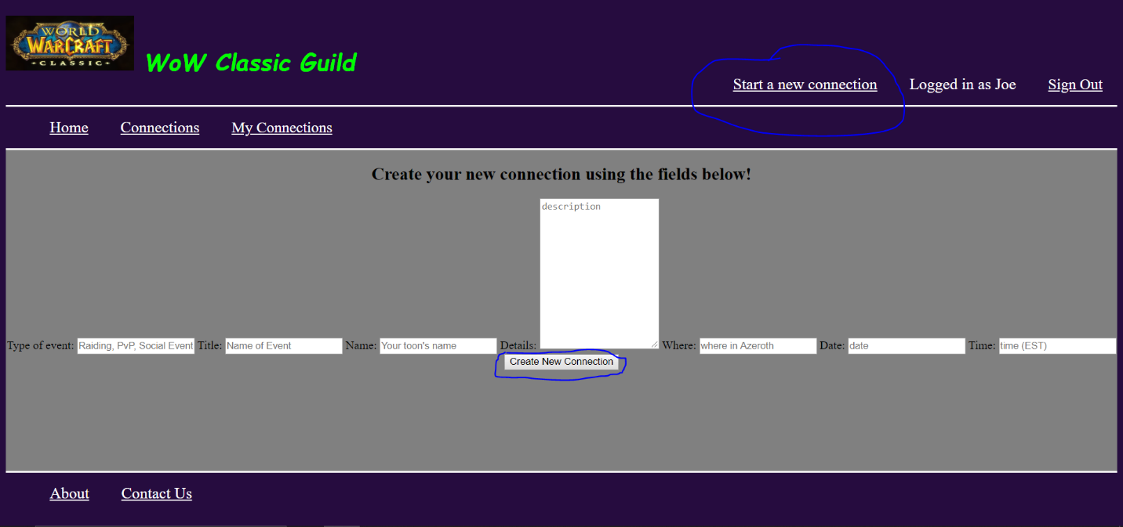Starting a connection and updating one both require the user to be logged in. If not logged in, refer to II. To start a new connection, simply click on the “Start a new connection” link located in the top right corner.
* 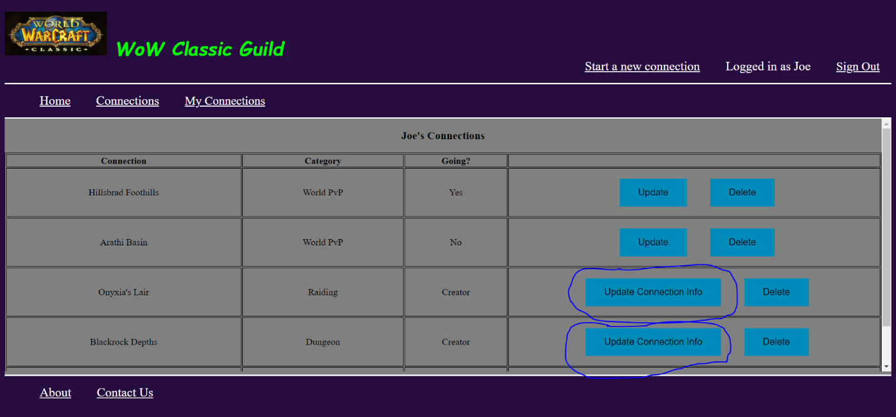To update a connection, you must be its creator. Navigate to your saved connections or profile (you can do this by clicking on “My Connections” in the top left) and then click on the button labeled “Update Connection Info” for the connection you wish to update (circled in blue in the picture below).
* This will bring you to the update connection page which is almost identical to the start a new connection page. Update it with the appropriate information of your choosing and click on the “Update Connection” button and it will be updated in the database and also updated for everyone that saved your 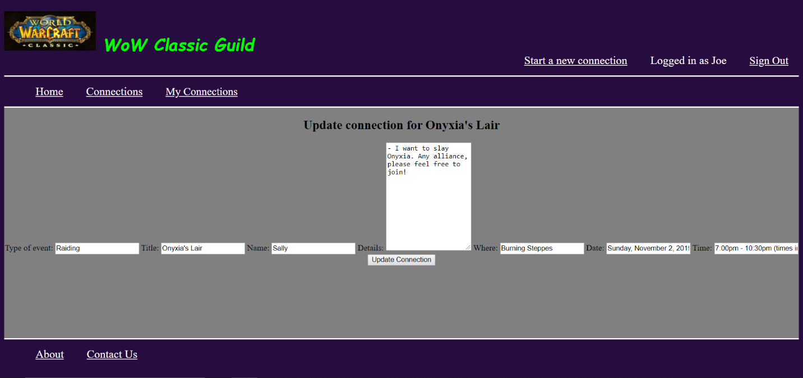connection.

**V. Sign out**

* Once you’re done making adding/updating/deleting connections to your profile and you wish to log-out, simply click on the “Sign Out” link in the top-right corner and you will be logged out and redirected to the homepage!

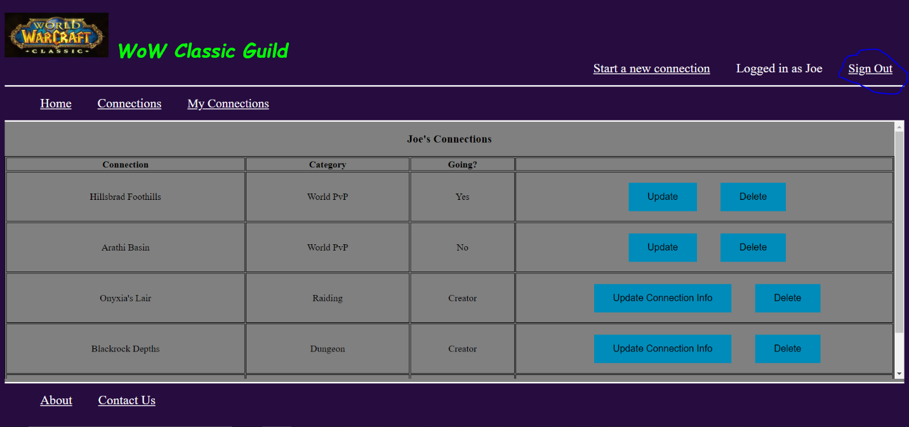

* If you are not logged in, you are still able to view all of the connections that other players have created as well as visit their info pages and browse our contact and about pages noted by links in the bottom left corner.

**VI. Sample User Information**

* Username: “jspringer”, Password: “1234” for Jerry
* Username: “bbuilder”, Password: “qwer” for Bob
* Username: “bhader”, Password: “asdf” for Bill
* Username: “hpotter”, Password: “zxcv” for Harry
* Username: “jswanson”, Password: “5678” for Joe